Supporting Information

Elevated atmospheric CO₂ concentrations alter grapevine (Vitis vinifera) systemic transcriptional response to European grapevine (Lobesia botrana) herbivory

Annette Reineke*, Moustafa Selim
Geisenheim University, Department of Crop Protection, Von-Lade-Str. 1, D-65366 Geisenheim, Germany

*Corresponding author:
Annette Reineke
Geisenheim University, Department of Crop Protection
Von-Lade-Str. 1, D-65366 Geisenheim, Germany
Tel.: ++49-6722-502413
Fax.: ++49-6722-502410
email: annette.reineke@hs-gm.de

Supplementary Table S1. RNA-Seq data statistics of 24 grapevine leaf samples obtained from (1) two different levels of CO₂ concentration (ambient: a; elevated: e) and (2) exposed (Lb) or not exposed (C) to L. botrana herbivory at (3) two grapevine growth stages (fruit development: –f; berry ripening: –b). Three RNA pools (indicated by 1, 2, 3) representing 3 biological replicates (each from one FACE ring) for each CO₂ concentration, treatment and growth stage were sequenced.

Sample ID | SRA accession | Total reads (raw) | Total reads (trimmed) | GC (%) | Overall read mapping ratio (%)
aC-f1 | SAMN08093445 | 15,861,402 | 15,555,428 | 49.51 | 72.4
aC-f2 | SAMN08093447 | 15,578,870 | 15,213,498 | 46.61 | 84.9
aC-f3 | SAMN08093449 | 14,067,862 | 13,770,790 | 46.64 | 85.6
eC-f1 | SAMN08093451 | 18,598,222 | 18,114,812 | 46.76 | 85.6
eC-f2 | SAMN08093453 | 4,958,804 | 4,864,628 | 47.6 | 79.9
eC-f3 | SAMN08093455 | 16,849,062 | 16,500,380 | 48.89 | 78.0
aLb-f1 | SAMN08093457 | 17,016,456 | 16,702,712 | 48.78 | 70.0
aLb-f2 | SAMN08093459 | 17,117,838 | 16,760,802 | 48.41 | 74.7
aLb-f3 | SAMN08093461 | 14,647,170 | 14,334,176 | 46.96 | 83.3
eLb-f1 | SAMN08093463 | 17,451,360 | 17,030,680 | 46.19 | 85.7
eLb-f2 | SAMN08093465 | 15,676,426 | 15,342,104 | 47.24 | 83.8
eLb-f3 | SAMN08093467 | 17,509,502 | 17,154,298 | 48.82 | 73.0
aC-b1 | SAMN08093469 | 18,747,522 | 18,354,022 | 51.76 | 52.1
aC-b2 | SAMN08093471 | 17,046,064 | 16,665,326 | 48.91 | 77.0
aC-b3 | SAMN08093473 | 16,464,372 | 16,105,806 | 50.95 | 62.8
eC-b1 | SAMN08093475 | 16,614,502 | 16,312,410 | 51.17 | 55.0
eC-b2 | SAMN08093477 | 13,706,066 | 13,444,896 | 48.35 | 75.7
eC-b3 | SAMN08093479 | 16,668,752 | 16,269,546 | 46.97 | 77.7
aLb-b1 | SAMN08093481 | 17,324,706 | 16,978,112 | 50.32 | 60.6
aLb-b2 | SAMN08093483 | 15,903,092 | 15,561,132 | 50.37 | 65.8
aLb-b3 | SAMN08093485 | 14,584,348 | 14,217,714 | 49.73 | 68.4
eLb-b1 | SAMN08093487 | 15,679,026 | 15,338,534 | 51.14 | 56.7
eLb-b2 | SAMN08093489 | 12,970,936 | 12,690,658 | 48.85 | 71.9
eLb-b3 | SAMN08093491 | 17,171,906 | 16,781,556 | 46.63 | 80.8

Supplementary Table S2. Genes involved in “plant-pathogen interaction”, “defence response” or “response to biotic stimuli” as identified by GO enrichment analysis or via KEGG database classification in grapevine plants (growth stage fruit development) as a response to L. botrana herbivory at elevated CO₂ and ambient CO₂ concentrations. IDs are according to GenBank entries, fold change of expression levels of genes in three pairwise comparisons is shown only for significant genes (p < 0.05). For sample codes see Supplementary Table S6. Expression of genes printed in bold letters was validated by RT-qPCR.
Gene_ID | Protein_ID | Description | Fold change
 |  |  | aLb-f vs. aC-f | eLb-f vs. eC-f | eLb-f vs. aLb-f
100266543 | XP_010657614.1 | brassinosteroid insensitive 1-associated receptor kinase 1-like | 2.627 | 2.996
100243573 | XP_002278179.1 | calcium-dependent protein kinase 2 | 2.088 | 2.596
100248850 | XP_002267099.1 | calcium-dependent protein kinase 28 |  | 2.365
100253496 | XP_002274476.1 | calcium-binding allergen Ole e 8-like | 2.533 | 4.695
100244152 | XP_002283755.1 | calmodulin-like protein 11 | 2.166
100255889 | XP_002282351.2 | caltractin | 2.062
100263254 | XP_010649201.1 | probable calcium-binding protein CML41 | 2.974
100267648 | XP_002273785.1 | endoplasmin homolog | 2.222 | 2.222
100233033 | NP_001267967.1 | enhanced disease susceptibility 1 (EDS1) | 2.494 | 3.091
100250236 | XP_002283967.2 | lipase-like PAD4 | 6.804 | 6.970
100253457 | XP_002280786.1 | lipase-like PAD4 | 6.463 | 11.268
100257078 | XP_002280729.1 | lipase-like PAD4 | 7.493 | 10.771
100241155 | XP_002281195.1 | probable disease resistance protein At1g12280 | 2.109 | 2.195
104881039 | XP_010657950.1 | probable disease resistance protein At4g27220 | 2.376 | 2.924
100853252 | XP_010652660.1 | probable disease resistance protein At5g66900 |  | 3.037
100854398 | XP_010658280.1 | putative disease resistance protein At1g50180 |  | -2.161
100244083 | XP_002276170.1 | protein SGT1 homolog |  | 2.107
100252764 | XP_002268128.2 | uncharacterized aarF domain-containing protein kinase At1g79600, chloroplastic-like |  | -2.037
100854803 | XP_003633333.1 | disease resistance protein RPM1-like |  | 2.044
100256051 | XP_002275317.3 | disease resistance protein RPM1-like | 3.582 | 3.055
100852949 | XP_003632405.1 | disease resistance protein RPM1-like | 2.058 | 2.540
100267151 | XP_010657373.1 | G-type lectin S-receptor-like serine/threonine-protein kinase At4g03230 | 2.6289 | 2.225
100246525 | XP_002274785.1 | major allergen Pru av 1 | 3.414 |  | -2.045
100261887 | XP_002274535.1 | major allergen Pru av 1 | 2.661 |  | -2.814
100256795 | XP_002274617.1 | major allergen Pru av 1 |  |  | -2.796
100233053 | NP_001267997.1 | mildew resistance locus o 15 (MLO15) | 2.362 | 2.524
100233063 | NP_001268013.1 | MLO11 protein | 3.274 | 3.051
100233061 | XP_002276608.1 | MLO-like protein 10 | 2.225 | 2.362
100267074 | NP_001267956.1 | pathogenesis-related protein 10.3 | 3.891
100258426 | XP_002273815.2 | pathogenesis-related protein 10.8 |  | -3.257
100267750 | XP_002283780.1 | allene oxide synthase |  | 2.707

Supplementary Table S3. Genes identified by GO enrichment analysis in grapevine plants (growth stage berry ripening) as a response to L. botrana herbivory at elevated CO₂ and ambient CO₂ concentrations. IDs are according to GenBank entries, fold change of expression levels of genes in two pairwise comparisons is shown only for significant genes (p < 0.05). For sample codes see Supplementary Table S6.

GO Term(s) | Gene_ID | Protein_ID | Description | Fold change
 |  |  |  | eLb-b vs. eC-b | eLb-b vs. aLb-b
GO:0003700 | 100247374 | XP_002276500.1 | transcription factor BEE 3 | 2.272
GO:0003700 | 100264451 | XP_002279570.1 | zinc finger protein ZAT10 | -2.186
GO:0003677 | 100265533 | XP_002284384.1 | zinc finger protein ZAT11 |  | -2.636
GO:0003700 | 100241331 | XP_010653659.1 | transcription elongation factor SPT6 |  | 2.133
GO:0003700; GO:0003677 | 100242144 | XP_002276215.1 | ethylene-responsive transcription factor 4 |  | -2.254
GO:0003700; GO:0003677 | 100243417 | XP_002279760.1 | ethylene-responsive transcription factor 12 |  | -2.164
GO:0003700; GO:0003677 | 100254640 | XP_002270581.2 | ethylene-responsive transcription factor 2 |  | -2.031

Supplementary Table S4. Expression of eight genes involved in grapevine’s response (growth stage fruit development) to L. botrana herbivory at elevated CO₂ and ambient CO₂ concentrations. Expressions were assessed by RT-qPCR in three biological replicates per treatment (herbivory and control) and CO₂ concentration. The normalized relative fold change of expression levels in three pairwise comparisons is shown with the 95% confidence interval. Significant differences in expression ratios at p < 0.05 are indicated by an asterisk. Significant differences in expression ratios after Bonferroni corrections are indicated by two asterisks. For sample codes see Supplementary Table S6.

 |  | Ratio
Gene ID | Gene | aLb-f vs. aC-f (95% CI) | eLb-f vs. eC-f (95% CI) | aLb-f vs. eLb-f (95% CI)
100266543 | brassinosteroid insensitive 1-associated receptor kinase 1-like (cdpk1) | 1.68 (0.5; 5.7) | 2.40 (1.6; 3.6) * | 0.78 (0.3; 2.5)
100253496 | calcium-binding allergen Ole e 8-like (cba8) | 2.91 (0.9; 9.4) | 5.36 (2.8; 1.0) ** | 0.73 (0.2; 2.4)
100233033 | enhanced disease susceptibility 1 (eds1) | 2.48 (0.8; 7.3) | 3.46 (1.7; 7.2) * | 0.90 (0.3; 2.7)
100256051 | disease resistance protein RPM1-like (drp1) | 1.87 (0.4; 8.1) | 2.59 (2.1; 3.2) ** | 0.82 (0.2; 3.5)
100233061 | mildew resistance locus o 10 (mlo10) | 3.06 (1.8; 5.3) * | 3.16 (2.2; 4.6) ** | 0.94 (0.7; 1.3)
100267074 | pathogenesis-related protein 10.3 (pr10.3) | 1.02 (2.4; 4.3) * | 3.95 (5.8; 2.7) | 1.8 (0.3; 1.2)
100258426 | pathogenesis-related protein 10.8 (pr10.8) | 0.60 (1.2; 2.9) | 4.7 (3.6; 6.1) ** | 1.2 (0.2; 6.8)
100267750 | allene oxide synthase (aos) | 6.82 (2.9; 1.6) * | 4.09 (2.9; 5.8) ** | 1.57 (0.9; 2.8)

Supplementary Table S5. Expression of eight genes involved in grapevine’s response (growth stage berry ripe for harvest) to L. botrana herbivory at elevated CO₂ and ambient CO₂ concentrations. Expressions were assessed by RT-qPCR in three biological replicates per treatment (herbivory and control) and CO₂ concentration. The normalized relative fold change of expression levels in three pairwise comparisons is shown with the 95% confidence interval. No significant differences in expression ratios at p < 0.05 were evident. For sample codes see Supplementary Table S6.

 |  | Ratio
Gene ID | Gene | aLb-b vs. aC-b (95% CI) | eLb-b vs. eC-b (95% CI) | aLb-b vs. eLb-b (95% CI)
100266543 | brassinosteroid insensitive 1-associated receptor kinase 1-like (cdpk1) | 1.01 (0.7; 1.5) | 1.14 (0.7; 1,8) | 0.76 (0.5; 1.1)
100253496 | calcium-binding allergen Ole e 8-like (cba8) | 1.08 (0.4; 2.9) | 1.54 (0.7; 3.2) | 0.63 (0.3; 1.3)
100233033 | enhanced disease susceptibility 1 (eds1) | 0.85 (0.4; 1.8) | 1.29 (0.6; 2.7) | 0.61 (0.2; 1.3)
100256051 | disease resistance protein RPM1-like (drp1) | 0.79 (0.2; 2.5) | 1.10 (0.6; 1.9) | 0.59 (0.2; 1.7)
100233061 | mildew resistance locus o 10 (mlo10) | 0.78 (0.4; 1.5) | 1,11 (0.9; 1.4) | 0.84 (0.6; 1.1)
100267074 | pathogenesis-related protein 10.3 (pr10.3) | 1.0 (0.3; 3.9) | 1.07 (0.3; 3.6) | 0.99 (0.2; 4.0)
100258426 | pathogenesis-related protein 10.8 (pr10.8) | 0.5 (0.05; 5.6) | 0.90 (0.2; 3.3) | 1.44 (0.5; 3.7)
100267750 | allene oxide synthase (aos) | 0.80 (0.3; 1.8) | 1.54 (0.8; 2.9) | 0.47 (0.2; 1.1)

Supplementary Table S6. Weather conditions during the experimental periods conducted in the Geisenheim VineyardFACE facility in July and September 2015.
Date 2015 | Air temperature [°C] |  |  | Soil temperature [°C] |  |  |  |  | Precipitation | Evaporation | Sunshine
 | Daily average | Max. | Min. | Daily average  5 cm | Daily average  10 cm | Daily average  20 cm | Daily average  50 cm | Daily average  100 cm | Daily sum  [mm] | Haude - Gras [mm] | Daily sum  [hours]
15. Jul | 22.6 | 29.4 | 16.1 | 26.7 | 26.1 | 24.6 | 22.6 | 21.1 | 0.0 | 5.8 | 9.6
16. Jul | 25.4 | 32.6 | 18.0 | 29.5 | 28.6 | 26.8 | 23.7 | 21.1 | 0.0 | 8.3 | 13.7
17. Jul | 27.3 | 35.3 | 20.0 | 29.4 | 28.7 | 27.5 | 24.7 | 21.4 | 0.8 | 11.2 | 8.9
18. Jul | 25.0 | 31.1 | 19.2 | 29.2 | 28.8 | 27.8 | 25.3 | 21.8 | 0.0 | 7.5 | 8.6
27. Sep | 13.9 | 18.8 | 9.2 | 13.6 | 14.0 | 14.7 | 15.5 | 16.3 | 0.0 | 3.0 | 9.0
28. Sep | 12.8 | 18.3 | 6.5 | 12.6 | 13.0 | 13.8 | 15.1 | 16.2 | 0.0 | 2.8 | 10.2
29. Sep | 13.4 | 18.9 | 6.9 | 12.6 | 12.9 | 13.7 | 14.8 | 16.1 | 0.0 | 2.9 | 8.0
30. Sep | 13.3 | 17.9 | 9.6 | 13.2 | 13.5 | 14.0 | 14.8 | 15.9 | 0.0 | 2.8 | 10.5

Supplementary Table S7. Description of grapevine treatments (two CO₂ concentrations, with and without L. botrana herbivory, two different grapevine phenological stages), and the resulting pairs of comparison with respective research questions.

Code | CO₂ concentration | Herbivory | Grapevine phenological stage
aC-f | ambient (ca. 400 ppm) | no | fruit development
aC-b |  |  | berries ripe for harvest
eC-f | elevated (ca. 450 ppm) | no | fruit development
eC-b |  |  | berries ripe for harvest
aLb-f | ambient (ca. 400 ppm) | yes | fruit development
aLb-b |  |  | berries ripe for harvest
eLB-f | elevated (ca. 450 ppm) | yes | fruit development
eLb-b |  |  | berries ripe for harvest
Pair | Question
aC-f vs. aLb-f/  aC-b vs. aLb-b | How do grapevine plants respond to L. botrana herbivory under ambient CO₂ concentration (at growth stages fruit development or berry ripening)?
eC-f vs. eLb-f/  eC-b vs. eLb-b | How do grapevine plants respond to L. botrana herbivory under elevated CO₂ concentration (at growth stages fruit development or berry ripening)?
aC-f vs. eC-f/  aC-b vs. eC-b | How do grapevine plants respond to elevated CO₂ concentration (at growth stages fruit development or berry ripening)?
aLb-f vs. eLb-f/  aLb-b vs. eLb-b | How do grapevine plants respond to elevated CO₂ concentration under L. botrana herbivory (at growth stages fruit development or berry ripening)?

Supplementary Table S8. Primer information for grapevine L. botrana herbivory responsive genes and two housekeeping genes (GADPH and cyclophilin) used for validation of RNA-Seq data by RT-qPCR.
Gene ID | Gene | Primer Sequence Forward | Primer Sequence Reverse | Amplicon (bp) | Efficiency (%) | R²
100266543 | brassinosteroid insen-sitive 1-associated receptor kinase 1-like (cdpk1) | 5’-AGGGGGCTTGCTTATTTGCATG-3’ | 5’-ATGCTTGCAGCCTTCACATCAC-3’ | 71 | 104.6 | 0.995
100253496 | calcium-binding aller-gen Ole e 8-like (cba8) | 5’-AGTTGCACGCGGTGTTCAAG-3’ | 5’-ACTCCTCGAAATTGACGCAACC-3’ | 111 | 108.5 | 0.966
100233033 | enhanced disease susceptibility 1 (eds1) | 5’-ACCCGTGGCTTTGCTATT-3’ | 5’-GGAAAGGTACTAGCATCCATCTT-3’ | 104 | 95.7 | 0.998
100256051 | disease resistance protein RPM1 (drp1) | 5’-AGTTCGCACAGAAGCTTATGCC-3’ | 5’-TGCTTAATGATCGCGAGCCTTG-3’ | 150 | 100.5 | 0.994
100233061 | mildew resistance locus o 10 (mlo10) | 5’-GGGCATCCATAATTCCCTTAGT-3’ | 5’-GGACCACTGCATGTCTTTCT-3’ | 105 | 85.4 | 0.986
100267074 | pathogenesis-related protein 10.3 (pr10.3) | 5’-GATGTTTTGACGAGCGGCATTG-3’ | 5’-TCTTTGCCGCCCTTAACGTG-3’ | 149 | 114.0 | 0.986
100258426 | pathogenesis-related protein 10.8 (pr10.8) | 5’-ATGGGTGTCACCAGTTTCACAC-3’ | 5’-AGCTTTGGGATCAGGTTGTTGG-3’ | 101 | 80.1 | 0.950
100267750 | allene oxide synthase (aos) | 5’-TTGCCACAACCTCCTTTTCGC-3’ | 5’-ATTGGGTGTGCAGTTTCACTCC-3’ | 113 | 108.9 | 0.966
100233024 | GAPDH | 5’-TCAAGGTCAAGGACTCTAACACC-3’ | 5’-CCAACAACGAACATAGGAGCA-3’ | 226 | 104.3 | 0.999
EC969926 | cyclophilin | 5’-GGAGCCTGAGCCTACCTTCTC-3’ | 5’-GTGTTCGGCCAGGTGGTAGA-3’ | 66 | 99.7 | 0.989

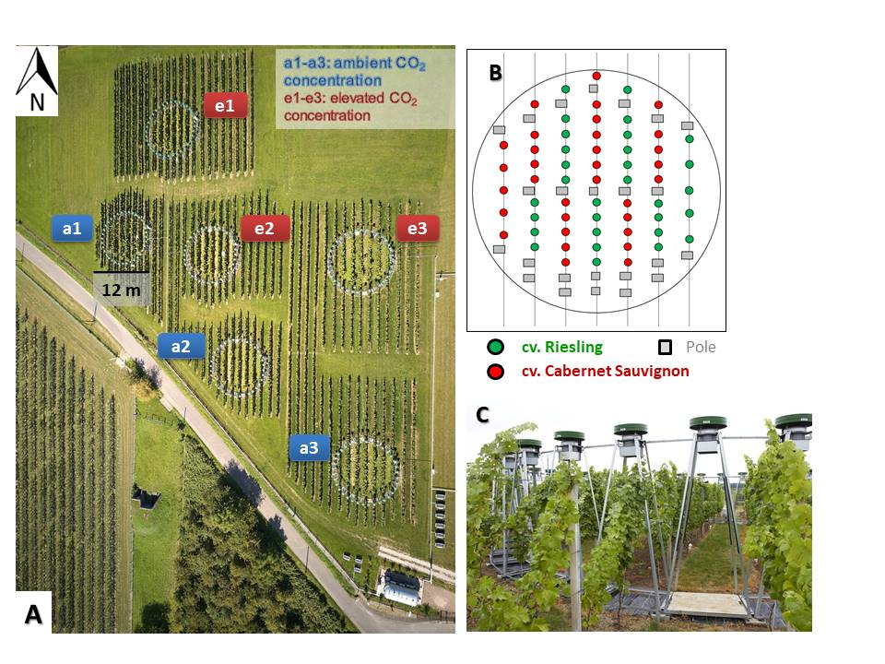
Supplementary Fig. S1: (A) Aerial view (picture by Winfried Schönbach) of the Geisenheim VineyardFACE experimental site showing localization of the three ambient CO₂ (designated as a1, a2 and a3) and three elevated CO₂ (designated as e1, e2 and e3) grapevine FACE rings. One ring has a diameter of 12 m. (B) Schematic illustration of one VineyardFACE ring planted with two different grapevine varieties (green dots: cv. Riesling and red dots: cv. Cabernet Sauvignon). Distance between rows is 1.80 m and between vines 0.90 m. (C) Detail of the Geisenheim VineyardFACE facility (picture by Winfried Schönbach).

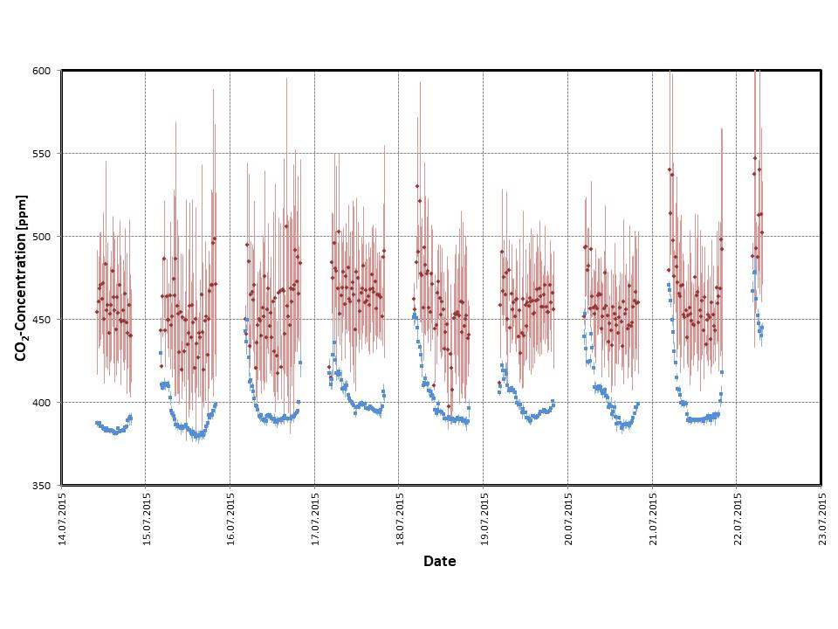Supplementary Fig. S2a: Daily CO₂ concentration measured in July 2015 at a height of 1.7 m in Geisenheim VineyardFACE rings with ambient (blue dots) and elevated (red dots) CO₂ concentration including standard error. CO₂ concentrations were measured in 20 min intervals between 4:20 and 20:00.
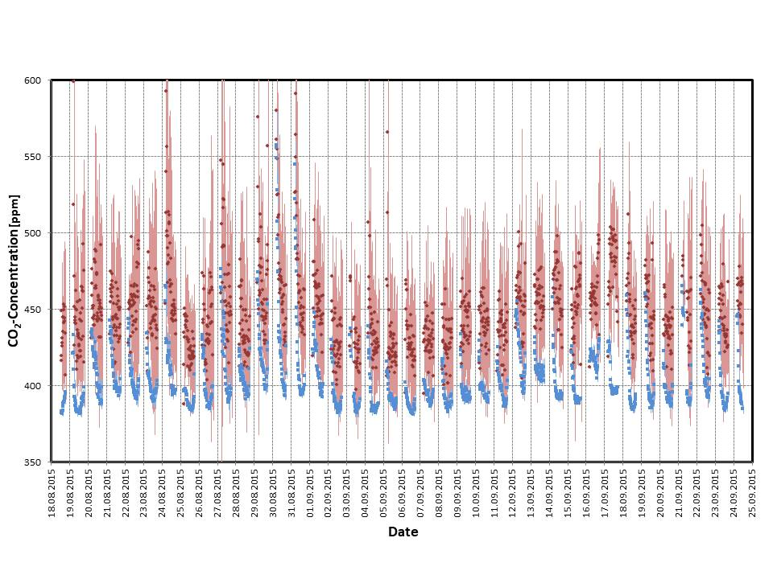Supplementary Fig. S2b: Daily CO₂ concentration measured from mid-August to end of September 2015 at a height of 1.7 m in Geisenheim VineyardFACE rings with ambient (blue dots) and elevated (red dots) CO₂ concentration including standard error. CO₂ concentration was measured in 20 min intervals between 5:20 and 19:00.

